Document owner | Document number | Date

Change Request Form

Change Request details
For guidance on how to complete this document please see the supporting Change Request guidance document

Change Request details
Change Request Title | CCAG proposals to change M6 and M7
Change Request Number | CR003
Originating Advisory / Working Group | CCAG – Cross Code Advisory Group
Risk/issue reference | I020
Change Raiser | Lawrence Jones, Elexon | Date raised: | 23/03/22

Part A – Description of proposed change
Guidance – This section should be completed by the Change Raiser when raising the Change Request.
Part A – Description of proposed change
Issue statement:
(what is the issue that needs to be resolved by the change)

M6 (‘Initial code changes drafted’) and M7 (‘Smart Meter Act powers enabled’) cannot be delivered as per the Ofgem Transition Plan in April 2022 and May 2023 respectively. In a design-led Programme, we need the design baselined before we draft Code changes and the Code changes drafted before the Smart Meter Act Powers are enabled, therefore this has resulted in a delay to when M6 and M7 can realistically be achieved and a requirement to re-plan the timelines.

Description of change:
(what is the change you are proposing)
Summary of the change:
- Move M6 to 9 months after M5
- Redefining M6 and renaming M6 to ‘Code changes baselined’
- Move M7 (Smart Meter Act Powers enabled) to 10 months after M5 (in line with the current 1-month lag behind M6)
Detail of the change:
The CCAG have undertaken a detailed planning exercise to understand the activities required to deliver MHHS code changes (plan, draft, approve and release). Please see Figure 1 below providing the output plan to M6 and M7. We are proposing delaying M6 by 9 months including:
- 1.75 months for preparation and planning (A), including impact assessment of the Programme design and development of a detailed plan for full code drafting.
- 5.75 months for full code drafting (B-J). This includes cycles of draft, consultation, and review. Code drafting will take place by topic area, with proposed topic areas: 4x large topics (Registration, Metering, BSC Central Services, Data Services) and 2x small topics (Governance, Interfaces). Code drafting will be primarily driven by BSC and REC, as this is where the largest changes occur. Changes to other codes will be drafted alongside and as a result of changes to BSC and REC during each topic area. There will also be a final drafting window for consequential changes to other codes. The detail of this code drafting phase will be planned up to and after M5 and will not necessarily be ‘waterfall’. This stage includes two ‘review’ periods to allow time to assess progress, review the plan and any changes to the design, and adjust the drafting approach.
- 1.25 months for a consistency check (K), to ensure the code drafted under each topic area fits together as a collective.
- 1.5 months to draft transition text (L). Some transition text may be drafted during full code drafting
- 1.5 months for completion (M-N). This is to collate outputs and complete final checks and plans before submission to Ofgem.
In addition to moving M6 timeframe, the CCAG are proposing changing the definition of M6 from ‘Initial code changes drafted’ to ‘Code changes baselined’. This means new M6 sits somewhere between old M6 and M8, as new M6 will be achieved when full code draft is complete from the Design Baseline and recommendations are delivered to Ofgem.
As in the current baseline plan, we are proposing that M7 be moved to 1 month after M6. This is because M7 needs to be delivered as late as possible while still in time for code releases (as code releases are dependent on M7). Activities under M7 (e.g., parliamentary approval) are to be delivered by Ofgem in parallel with activities for M6 (no M6 activities are dependent on M7, and vice versa). The use of SCR Mods are also being considered by CCAG, to supplement the Smart Meter Act Powers.
This plan as proposed is built using the best information currently available to the CCAG. The next layer of detail under this plan (to be completed by the CCAG up to and after M5) may find that different activities and amounts of time are required under some steps in the plan. Any proposed changes to milestones found during this more detailed planning activity will be included in the M5 Programme replan (should there be significant change).

Figure 1: CCAG code draft plan to M6 and M7
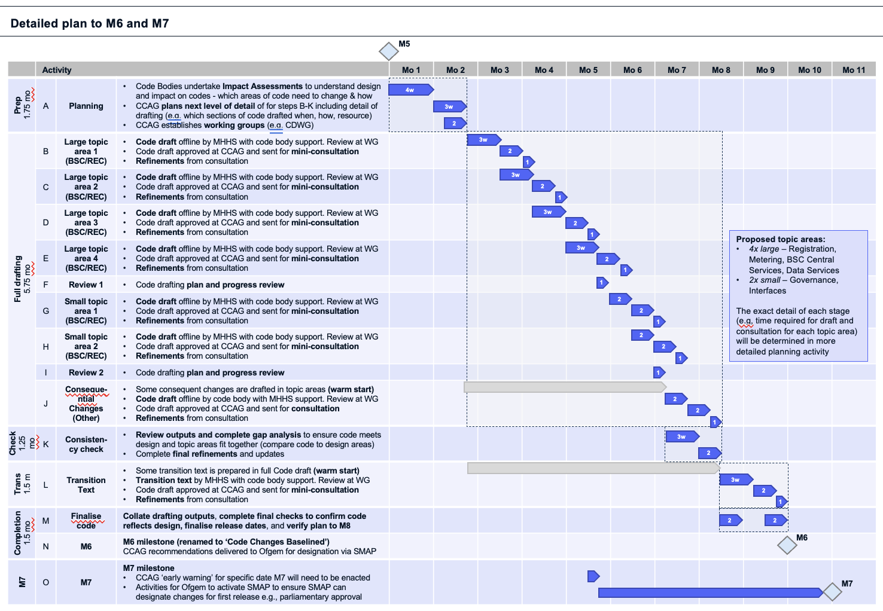

At this stage, the CCAG are proposing changes to M6 and M7 only. A change to M8 will be included in the Programme replanning activity after M5. A high-level view of activities required from M7 to M8 has been considered as part of the CCAG planning activity for this Change Request (Figure 2). This was to ensure that the proposals for M6 and M7 do not result in an M8 date that exceeds the date of qualification start. Qualification start is considered the M8 boundary condition as all code changes must be delivered before qualification. M9 has no dependency on M8 as the programme is design led (testing will be done against the design).

The timeframes provided in this plan are relative to M5 (no specific dates given). The detail of this Change Request should be considered independently from CR001 and CR002 (changes to M5).

Figure 2: CCAG high level plan to M10

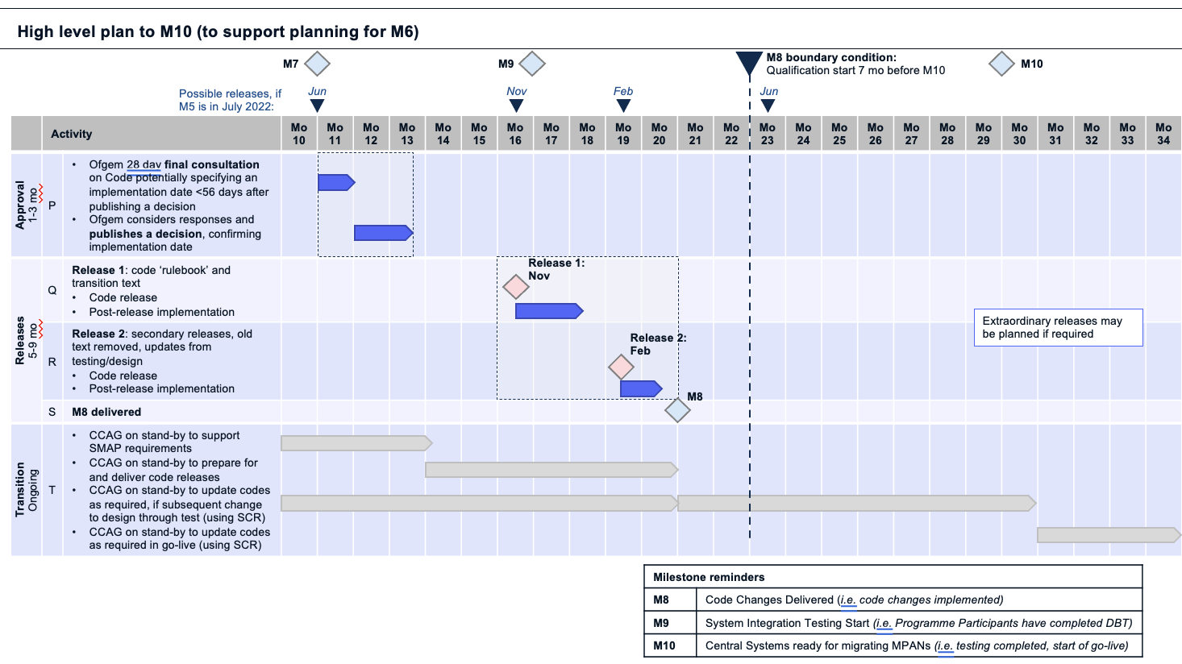

RAID
The CCAG has collated a list of Risks, Issues, Assumptions and Dependencies that underpin the rationale behind this plan. These will be raised to the Programme RAID framework if the Change Request is approved, with mitigations and scoring added.

Assumptions
 | Description | Impact
A1 | Code drafting has no dependency on the Programme replan (M5+3) | If code drafting is dependent on the replan, code drafting will be delayed 2-3 months
A2 | Code bodies will need to impact assess the design to understand its implications on required code changes so that a detailed code draft plan can be developed. Code drafting cannot begin until this has taken place | If code bodies do not require detailed impact assessment and planning, they can begin supporting code drafting sooner. M6 could be brought forward
A3 | Mini-consultations of draft code will take two weeks. There may be some flex in mini-consultation windows (longer/shorter) depending on the volume of documents to review | If mini-consultation require more than two weeks, full code drafting may be delayed
A4 | Code draft and consultation can happen in parallel for separate code draft topic areas | If these activities cannot occur in parallel, code drafting and M6 will be delayed
A5 | Code drafting can be broken into specific topic areas. These areas are distinct and will be drafted in series (waterfall). There will be insufficient resource to draft topic areas in parallel. | If there was more resource, code draft could occur over a shorter period of time
A6 | Code draft changes will be driven by BSC and REC as these are the codes with the largest changes. Changes to BSC and REC will inform changes to other codes, and these can be delivered at the same time as BSC and REC changes | The planning and delivery approach to topic areas must be reviewed
A7 | Code bodies will dedicate enough resource to support code changes in the timescales in the code draft plan | If code bodies do no dedicate enough resource, code drafting may take longer than planned
A8 | MHHS resource will coordinate and complete code drafting and subsidiary documents with support from code bodies | MHHS will drive code changes offline and via the Working Groups. MHHS and code bodies must plan resources as appropriate
A9 | Some consequential changes to codes outside of BSC and REC can be drafted during main BSC and REC code drafting (warm start). There is no dependency on all code drafting being delivered before consequential drafting starts | A longer period for consequential changes must be planned after the topic areas for all codes have been drafted
A10 | Transition text can be ‘warm started’ with some completed during standard code drafting | A longer period to draft transition text planned after the topic areas for all codes have been drafted
A11 | A consistency check is required to ensure all parts of drafted code ‘fit together’. This consistency check will only need ~3 weeks because the majority of work will have been completed during code drafting and in identification of consequential changes | Time for a consistency check is required after code drafting. If a consistency check is not required (e.g. it becomes clear that codes are consistent throughout the drafting process) then this step can be removed from the plan and M6 brought forward
A12 | No final consultation will be required by the Programme on code drafting before recommendation to Ofgem. Mini-consultations throughout drafting will be sufficient. (note Assumption 13) | If a final consultation is required, this must be added to the plan and M6 will be delayed
A13 | There will be few changes to the design and subsequent code following M5 such that dedicated contingency time to update code as a result is not required to be built into the code drafting plan | If there are significant changes to the design, additional code draft time will be required which may delay M6
A14 | The design will facilitate efficient and effective code drafting | If this is not the case, additional code draft time may be required which may delay M6
A15 | SMAP will be used to designate MHHS code changes | If SMAP is not used, the Programme will have to use SCR which may complicate the release process and increase release timescales
A16 | A final consultation will be required under SMAP. This will be 28 days | Time for a final consultation must be planned in after M7 and before the first code release
A17 | SMAP will be enacted by Ofgem/BEIS in time for to be used for the first planned MHHS code release | If SMAP is not ready for use for the first code release, this will delay code releases and M8, and may result in code changes being delivered after qualification
A18 | There are no actions required by Ofgem to designate MHHS code changes in addition to consultation and publication | If this is not the case, further time may need to be planned to deliver SMAP requirements in advance of code releases and M8
A19 | M7 is not dependent on any activities under M6 and vice versa. Code drafting is not required to go before Parliament. | M7 can start at any time during M6
A20 | M9 is not dependent on any activities under M6, M7 or M8 (the Programme is design led) and vice versa. Final code is not required for testing | M6, M7 and M8 can occur at any time around M9
A21 | The content and logical sequence of each code release will be determined in detail during code drafting. | Additional time has been factored into the code drafting phase to allow for release planning. If this is not the case, additional time may be required after code drafting to plan releases
A22 | Old code text will run in parallel with new code text during migration. Transition text will be required to refer between the two | Transition text must be drafted. Migration must take into account use of old, new and transition code

Dependencies
 | Description | Impact
D1 | Code drafting can only begin once the design has been completed (M5, as the Programme is design led) and subsequent impact assessment of the design by code bodies has been completed | Code drafting cannot begin until M5 is delivered
D2 | Different topic areas within the code draft phase will be dependent on each other and need to be drafted in a specific sequence. | If topic areas are not dependent on each other, drafting may be able to occur in parallel
D3 | Code draft approval is dependent on Code Bodies reviewing drafted code within each mini-consultation (and any final consultation/s) | If code bodies do not review drafted code in any consultations, the drafted code cannot be approved
D4 | Transition text can only be drafted for specific elements of code once the updates to that element are themselves drafted | A phase to draft transition text must be planned after code changes have been drafted
D5 | Code release content will depend on the following, to be determined during code drafting  - Lead times of longest implementation  - Content of code drafting: introduction of new arrangement text, transitional text and removal of legacy text  - Code release traffic (to avoid conflict with large/busy releases)  - Consideration of sunrise and sunset clauses  - Synchronised and coordinated with system changes | Planning activity for releases must be undertaken during code drafting
D6 | Code releases should be aligned to industry code release dates (Feb, Jun, Nov) unless an extraordinary release is scheduled | Code releases must be planned against Feb, Jun and Nov release dates. Activities leading up to releases must be delivered by these months
D7 | Full code changes must be delivered before qualification begins (M8 boundary condition is qualification) | All activities for M6, M7 and M8 must be delivered before qualification start (7 months before M10)

Risks
 | Description | Impact |  | Proposed mitigation(s)
R1 | The full extent of code drafting including timeframes will not be known until the design is complete and therefore more time may be required to deliver full code drafting than currently planned. Code drafting may not be completed in the timeframes given to M6 due to unknowns that will not be determined until after M5. |  | Additional time may be required to deliver code changes, delaying M6. Or additional resource may be required to deliver code changes to proposed M6 timelines | - Significant engagement Significant engagement with Code bodies and CCAG has been undertaken to understand likely timescales for all steps in the plan  - Dedicated planning time is incorporated in the plan (A – 1.75 months)  - 2x review periods have been incorporated into code drafting (F and I – 1 week each)  - Some planning work will be undertaken before M5
R2 | Limited contingency time has been included in the plan for unknowns that may delay drafting. |  | Unknowns may delay elements of the plan and hence delivery of M6 | - Significant engagement with Code bodies and CCAG has been undertaken to understand likely timescales for all steps in the plan  - Dedicated planning time is incorporated in the plan (A – 1.75 months)  - 2x review periods have been incorporated into code drafting (F and I – 1 week each)  - Some planning work will be undertaken before M5
R3 | Outputs of code changes from Faster Switching Programme go live in July 2022 may change the role/responsibility of different codes |  | This may impact/change the requirements of different codes/code bodies under MHHS. This will not be known until FSP go live | - Monitor likely outputs of FSP and their impacts on MHHS  - Factor possible changes to code responsibilities in code draft planning
R4 | There may be insufficient resource to deliver code changes aligned to the code draft plan due to resource requirements for MHHS design updates |  | Code changes may take longer to deliver than planned. Delay to one code may delay all codes, and therefore delay M6 | - Code draft resource planning is beginning now and will continue up to code drafting  - Steps of the plan have been structured to spread resource effectively
R5 | Code draft outputs may not reflect the design |  | The execution of the code may not work in practice and future Changes Requests may be required to re-draft the code | - A ‘consistency check’ is planned (K – 1.25 months) to complete a gap analysis and ensure the code reflects the design  - Code drafting will be undertaken by MHHS design resource (who know the design)  - An impact assessment of the design on codes has been planned (A – 1.75 months)  - Mini-consultations on the code are planned throughout drafting
R6 | Ofgem may choose not to enact SMAP for MHHS code changes and therefore code change would need to happen via SCR which would add delay and complexity to releases |  | If SMAP is not ready for use for the first code release, this will delay code releases and M8 and may result in code changes being delivered after qualification | - The CCAG have developed and shared a recommendation with Ofgem  - Lead times to M7 are sufficient for further discussion and to prepare for SCR if required
R7 | There may be changes to the design following design baseline that extend or require rework of the code draft plan and/or code itself | Additional time will be required to deliver code updates, delaying M6 |  | - The CCAG has/will consider their approach to reviewing and updating code, should the design change e.g., maintaining working groups on stand-by  - Code drafting begins after the design is complete, with a 1.75 month window before drafting starts  - The plan has included 2x review periods (F and I – 1 week each) to review progress and plan
R8 | Programme testing may identify changes to baselined code and require code updates and further code releases after initial code changes have been approved | Additional time will be required to deliver code updates, delaying M6 and/or M8 |  | - The CCAG has/will consider their approach to reviewing and updating code, should the design change e.g., maintaining working groups on stand-by
R9 | MHHS resource may be tied up with post-design ‘wash up’ and be unable to start code drafting against the given timescale | Code drafting and M6 will be delayed |  | - Code draft resource planning is starting in March 2022. Resource requirement vs forecast will be assessed to determine any gaps  - A 1.75 month planning period before code draft allows some time for design resource to finish design and move under CCAG
R10 | Timeframes for enabling SMAP and hence delivering code changes via SMAP may be longer than planned | Delay to M8 that may push M8 beyond qualification |  | - Planning for enabling SMAP has begun in March 2022 including providing a CCAG recommendation to Ofgem to use SMAP and mapping the steps before/after M7 to ensure its delivery timescale is realistic  - A SMAP ‘trigger’ has been included in the plan to ensure SMAP are enabled in time

Justification for change:
(please attach any evidence to support your justification)
M6 and M7 were built in the Ofgem Transition Plan before the Programme had been agreed to be design-led. Under the Ofgem Transition Plan, the Programme design and code draft were to happen in parallel.
In the design-led model, Code drafting must begin after the design is baselined at M5, therefore the plan must change to align with the design-led approach, as highlighted by CCAG to the MHHS Programme and the PSG.
Not aligning to the design-led model would undermine a basic principle of the Programme approach. Delivering against the original Ofgem Transition Plan for M6 & M7 would have:
- Required significant additional resource in the time to M5/M6 to complete design and Code development activities in parallel, including resource to review and ensure consistency
- Introduced significant technical risk of discrepancies between Code changes and design if both delivered at the same time. This would have significantly increased risk of future change to design and code that would have increased Programme cost and delivery timescales
The proposals in this change requests results in a thinner, longer resource model that will more efficiently deploy the same resource for continuous activity, rather than ramping up and ramping down higher resource. It also allows for SME resource to spread themselves across design and code draft activity.

Consequences of no change:
(what is the consequence of no change)
- M6 and M7 will not be delivered as per the current baselined plan (Ofgem Transition Plan).
- M6 and M7 will be marked as overdue until the times described in this plan.
- The CCAG and wider Programme Participants will not be able to plan effectively to M8.
- The Programme would have to incur significant additional cost to begin code drafting including through a rapid increase in resource and by redefining the design/code delivery model
Target date by which a decision is required: | 27 April 2022 (April CCAG)  This ensures the change is approved before the current M6 date

Part B – Initial Impact of proposed change
Guidance – This section should be completed by the Change Raiser before being submitted to the MHHS PMO.
Guidance – Please document the benefits of the change and to delivery of the programme objectives
What benefits does the change bring
(list the benefits of the change and how this improves the business case)
- The Programme will be design led and code changes will be drafted as a result of the design.
- The Programme baseline plan will accurately reflect the timeframes required for delivering MHHS code changes.
- Resource can be deployed more efficiently.
- Programme code changes will be delivered to a higher quality/accuracy by Code drafting after the design baseline, mitigating consistency issues and reducing the risk of future change and associated cost and time delay. Issue resolution becomes more expensive to resolve the later in the programme that issues are identified.
- The CCAG and wider Programme Participants will be able to plan more effectively to M8.

Programme Objective | Benefit to delivery of the programme objective
To deliver the Design Working Group’s Target Operating Model (TOM) covering the ‘Meter to Bank’ process for all Supplier Volume Allocation Settlement meters | Delivered to higher standard than if the Programme continues against the baseline code draft plan
To deliver services to support the revised Settlement Timetable in line with the Design Working Group’s recommendation | Delivered to higher standard than if the Programme continues against the baseline code draft plan
To implement all related Code changes identified under Ofgem’s Significant Code Review (SCR) | Delivered to higher standard than if the Programme continues against the baseline code draft plan
To implement MHHS in accordance with the MHHS Implementation Timetable | This change request does not materially impact the final delivery date for MHHS because of the dependencies highlighted in the CR.
To deliver programme capabilities and outcomes to enable the realisation of benefits in compliance with Ofgem’s Full Business Case | Delivered to higher standard and more efficiently than if the Programme continues against the baseline code draft plan.
To prove and provide a model for future such industry-led change programmes | This CR ensures consistency with the design-led principle that underpins the programme.

Guidance – Please document the known programme parties and programme deliverables that may be impacted by the proposed change
Impacted areas | Impacted items
Impacted Parties | Primarily Code Bodies and Programme code drafting resource. All participants in the review of Code changes
Impacted Deliverables | Any deliverables under code draft planning, drafting, approval and release
Impacted Milestones | M6, M7, M8

Initial assessment
Necessity of change |  | Expected lead time
Rationale of change |  | Expected implementation window
Expected change impact

Part C – Summary of impact assessment and recommendation

Guidance – This will be completed initially by the Change Raiser and then by Programme Participants as part of the full Impact Assessment
Note – All Impact Assessment responses will be considered public and non-confidential unless otherwise marked. If there are any specific elements of responses (e.g. costs) that are confidential, please can you mark those specific sections as confidential rather than the response as a whole.
Part C – Summary of impact assessment and recommendation (complete as appropriate)
Effect on benefits
Comments from Change Raiser:
Positively impacted as outputs of code drafting are more likely to reflect the design than if the Programme follows the current baseline plan. There will be no delay to benefits realisation.
Impact Assessment respondents to review and respond to content provided by the Change Raiser. Impact Assessment respondents to identify and describe any further impacts, quantifying where possible.

Effect on consumers
Comments from Change Raiser:
Positively impacted as outputs of code drafting are more likely to be delivered efficiently and reflect the design than if the Programme follows the current baseline plan. There will be no impact on go-live.
Impact Assessment respondents to review and respond to content provided by the Change Raiser. Impact Assessment respondents to identify and describe any further impacts, quantifying where possible.

Effect on schedule
Comments from Change Raiser:
The current M6 and M7 dates will be extended by 9 and 10 months respectively. The programme being design led enables code drafting and testing to occur in parallel, therefore the programme end date and other milestones (excluding M8) are not impacted.
The impact on M8 and beyond (where required) will be reassessed as part of the replanning exercise.
The timeframes provided in this Change Request are relative to the date for M5. Impact Assessment respondents should include any assumptions related to the impact of CR001 and CR002 Change Requests.
Impact Assessment respondents to review and respond to content provided by the Change Raiser. Impact Assessment respondents to identify and describe any further impacts, quantifying where possible.

Effect on costs
Comments from Change Raiser:
The same or less cost will be incurred. This is because the same or less resource will be required to deliver code changes with a reduced impact of parallel resource and less impact of ramp up and ramp down of resources. Less resource may be required because the code draft will be design led – code only needs to reflect the design and does not have to be built from zero. By completing design and code draft sequentially, SME resource can be more involved in both design and code drafting
Impact Assessment respondents to review and respond to content provided by the Change Raiser. Impact Assessment respondents to identify and describe any further impacts, quantifying where possible. Specific costs may be identified as confidential where necessary and aggregated by the MHHS Programme.

Effect on resources
Comments from Change Raiser:
The same or less code draft resource will be required in total, but this resource will be required over a longer period than the current baseline plan. The same or less resource will be required to deliver code changes with a reduced impact of parallel resource and less impact of ramp up and ramp down of resources. Less resource may be required in code drafting because the code draft will be design led – code only needs to reflect the design and does not have to be built from zero.
Impact Assessment respondents to review and respond to content provided by the Change Raiser. Impact Assessment respondents to identify and describe any further impacts, quantifying (e.g., resource type, duration, skills) where possible.

Effect on contract
Comments from Change Raiser:
Any contract impacts for Programme Parties will need to be assessed by those parties.
Impact Assessment respondents to review and respond to content provided by the Change Raiser. Impact Assessment respondents to identify and describe any further impacts, quantifying where possible.

Risks
Comments from Change Raiser:
Please see RAID items above for risks related to the plan as identified by the Change Raiser.
There are related Programme risks in the RAID Management Framework:
R076: There is a risk that the design led approach does not get board level attention to mobilise programme party programmes until the regulations are laid (M8 rather than M5)
R028 - Risk that Industry may not be capable of adopting a delivery-based approach (design-led not code-led) and will therefore revert to normal delivery procedures for MHHS
Impact Assessment respondents to review and respond to content provided by the Change Raiser. Impact Assessment respondents to identify and describe any further risks.

Recommendation
Comments from Change Raiser:
It is recommended the change is approved

Impact assessment done by: <Name>

Guidance: If you are a third party responding on behalf of another Programme Participant, please state this in your response.

Impact assessment completed on behalf of: <Name>

Guidance: The approvals section will be completed by the MHHS PMO once the Impact Assessment has been reviewed.

Approvals (to be completed by MHHS PMO)
Decision authority level
<Based on the impact assessment, state who is required to make a decision concerning this change>

Part D – Change decision
Guidance - This section will be completed by the MHHS PMO following the review of the impact assessment and decision reached by the SRO.
Part D – Change decision
Decision: |  | Date
Approvers:
Change Owner:
Action:
Changed Items | Pre-change version |  | Revised version

Part E – Implementation completion
Guidance - This section will be completed by the MHHS PMO at the end of the post-implementation process.
Part E – Implementation completion
Comment |  | Date

Guidance – This section will be completed by the MHHS PMO at the end of the post-implementation process and should be used to add any appropriate references of the change once it has been completed.
References
Ref | Document number | Description

